Given an integer n and an integer array rounds. We have a circular track which consists of n sectors labeled from 1 to n. A marathon will be held on this track, the marathon consists of m rounds. The ith round starts at sector rounds[i - 1] and ends at sector rounds[i]. For example, round 1 starts at sector rounds[0] and ends at sector rounds[1]

Return *an array of the most visited sectors* sorted in **ascending** order.

Notice that you circulate the track in ascending order of sector numbers in the counter-clockwise direction (See the first example).

**Example 1:**

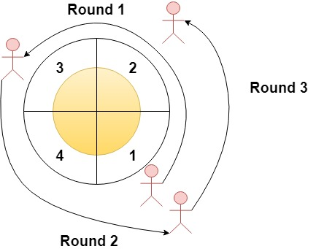

**Input:** n = 4, rounds = [1,3,1,2]

**Output:** [1,2]

**Explanation:** The marathon starts at sector 1. The order of the visited sectors is as follows:

1 --> 2 --> 3 (end of round 1) --> 4 --> 1 (end of round 2) --> 2 (end of round 3 and the marathon)

We can see that both sectors 1 and 2 are visited twice and they are the most visited sectors. Sectors 3 and 4 are visited only once.

**Example 2:**

**Input:** n = 2, rounds = [2,1,2,1,2,1,2,1,2]

**Output:** [2]

**Example 3:**

**Input:** n = 7, rounds = [1,3,5,7]

**Output:** [1,2,3,4,5,6,7]

**Constraints:**

* 2 <= n <= 100
* 1 <= m <= 100
* rounds.length == m + 1
* 1 <= rounds[i] <= n
* rounds[i] != rounds[i + 1] for 0 <= i < m